SCHOOL OF COMPUTER SCIENCE AND ARTIFICIAL INTELLIGENCE |  |  |  |  | DEPARTMENT OF COMPUTER SCIENCE ENGINEERING
ProgramName:B. Tech |  |  |  | Assignment Type: Lab |  |  | AcademicYear:2025-2026
CourseCoordinatorName |  |  |  | Venkataramana Veeramsetty
Instructor(s)Name
 |  |  |  | Dr. V. Venkataramana (Co-ordinator)
 |  |  |  | Dr. T. Sampath Kumar
 |  |  |  | Dr. Pramoda Patro
 |  |  |  | Dr. Brij Kishor Tiwari
 |  |  |  | Dr.J.Ravichander
 |  |  |  | Dr. Mohammand Ali Shaik
 |  |  |  | Dr. Anirodh Kumar
 |  |  |  | Mr. S.Naresh Kumar
 |  |  |  | Dr. RAJESH VELPULA
 |  |  |  | Mr. Kundhan Kumar
 |  |  |  | Ms. Ch.Rajitha
 |  |  |  | Mr. M Prakash
 |  |  |  | Mr. B.Raju
 |  |  |  | Intern 1 (Dharma teja)
 |  |  |  | Intern 2 (Sai Prasad)
 |  |  |  | Intern 3 (Sowmya)
 |  |  |  | NS_2 ( Mounika)
CourseCode |  |  | 24CS002PC215 | CourseTitle |  | AI Assisted Coding
Year/Sem |  |  | II/I | Regulation |  | R24
Date and Day  of Assignment |  |  | Week1 - Thursday | Time(s)
Duration |  |  | 2 Hours | Applicableto Batches |  | 24CSBTB01 To 24CSBTB39
AssignmentNumber:2.4(Present assignment number)/24(Total number of assignments)
 | Q.No. | Question |  |  |  |  |  |  | ExpectedTi me  to complete
 | 1 | Lab 2: Exploring Additional AI Coding Tools – Gemini (Colab) and Cursor AI  Lab Objectives: |  |  |  |  |  |  | Week1 - Thursday

- To explore and evaluate the functionality of Google Gemini for AI-assisted coding within Google Colab.
- To understand and use Cursor AI for code generation, explanation, and refactoring.
- To compare outputs and usability between Gemini, GitHub Copilot, and Cursor AI.
- To perform code optimization and documentation using AI tools.

Lab Outcomes (LOs):
After completing this lab, students will be able to:

- Generate Python code using Google Gemini in Google Colab.
- Analyze the effectiveness of code explanations and suggestions by Gemini.
- Set up and use Cursor AI for AI-powered coding assistance.
- Evaluate and refactor code using Cursor AI features.
- Compare AI tool behavior and code quality across different platforms.

Task Description #1
- Open Google Colab and use Google Gemini to generate Python code that performs sorting of a list using both the bubble sort algorithm and Python’s built-in sort() function. Compare the two implementations.
Expected Output #1
- Two sorting implementations: Bubble sort (manual logic) and Built-in sort()

ANSWER:
PROMPT:- Generate Python code that performs sorting of a
list using both the bubble sort algorithm and Python’s built-in sort() function. SCREENSHOT:-
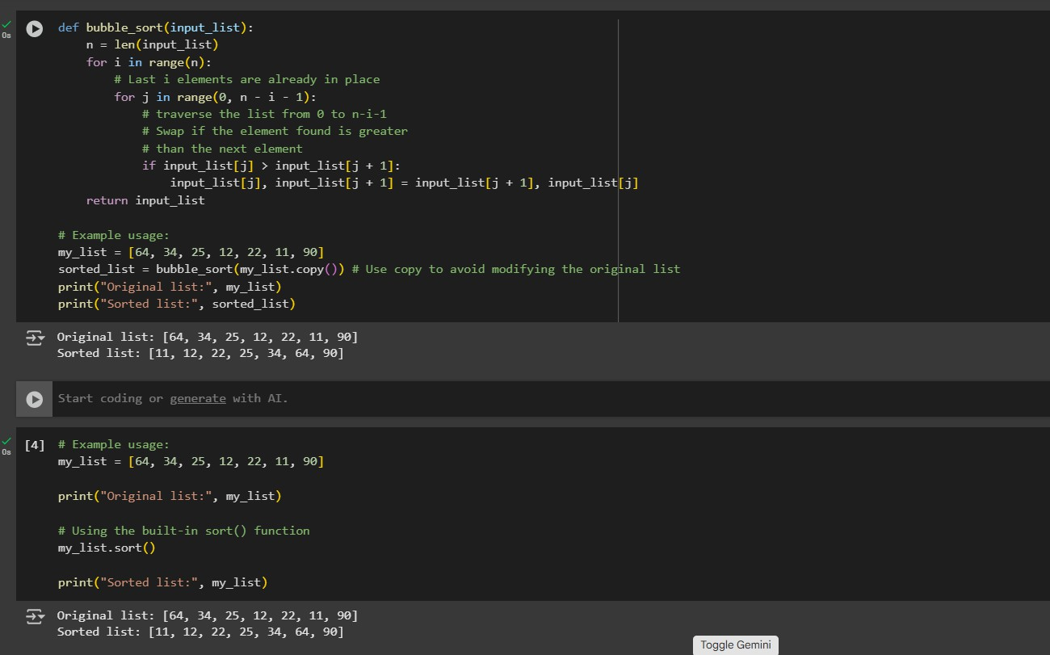
COMPARISONS;
- BUBBLE SORT:Generally inefficient for large datasets.
- Built In(sort):Generally efficient for most the cases.

Task Description #2
- In Colab, use Google Gemini to generate a Python function that takes a string and returns: The number of vowels, The number of consonants, The number of digits in the string Expected Output #2-
- Complete function that Iterates through characters of a string and Counts vowels, consonants, and digits

ANSWER:
Prompt: A Python function that takes a string and returns:
The number of vowels, The number of consonants, The number of digits in the string SCREENSHOT:
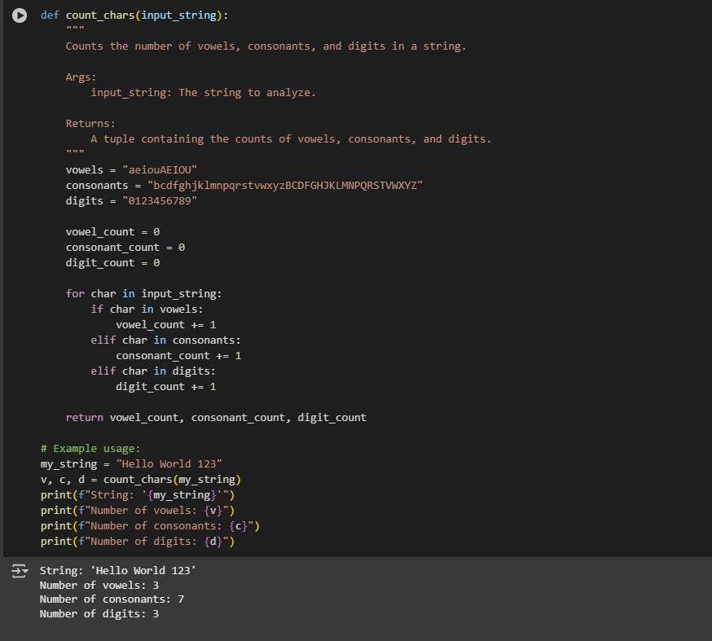

OBSERVATION:
The count_chars function successfully analyzed the string "Hello World 123" and returned the counts of vowels, consonants, and digits.

Task Description #3
- Install and set up Cursor AI. Use it to generate a Python program that performs file handling: Create a text file
Write sample text
Read and display the content
Expected Output #3
- Functional code that creates a .txt file, writes content to it, and reads it back.
- Screenshot of GEMINI AI interface showing: Prompt used, Generated code, Output of file operations

ANSWER:
PROMPT: Write a python code that performs file handling,create a text file then read and display the content.

SCREENSHOT:
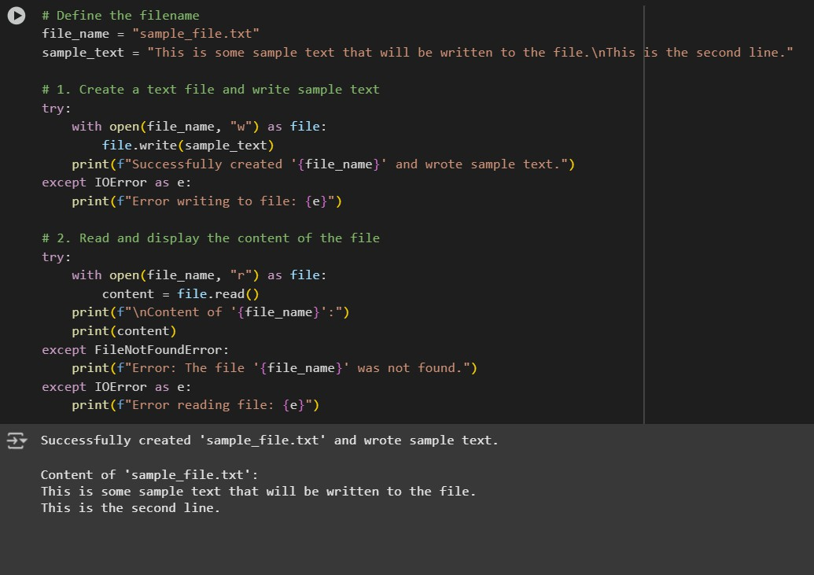
OBSERVATION:
- It created a file named sample_file.txt.
- It wrote the sample text into this file.
- It read the content from the file.
- It displayed the content of the file, which matches the sample text that was written.

Task Description #4
- Ask Google Gemini to generate a Python program that implements a simple calculator using functions (add, subtract, multiply, divide). Then, ask Gemini to explain how the code works. Expected Output #4
- Complete calculator code with user input and operation selection.
- Line-by-line explanation or markdown-style explanation provided by Gemini.
- Screenshot of both the code and explanation in Colab.
ANSWER:
PROMPT:A python program that implements a simple calculator using functions(add, subtract, multiply, divide).
SCREENSHOT:

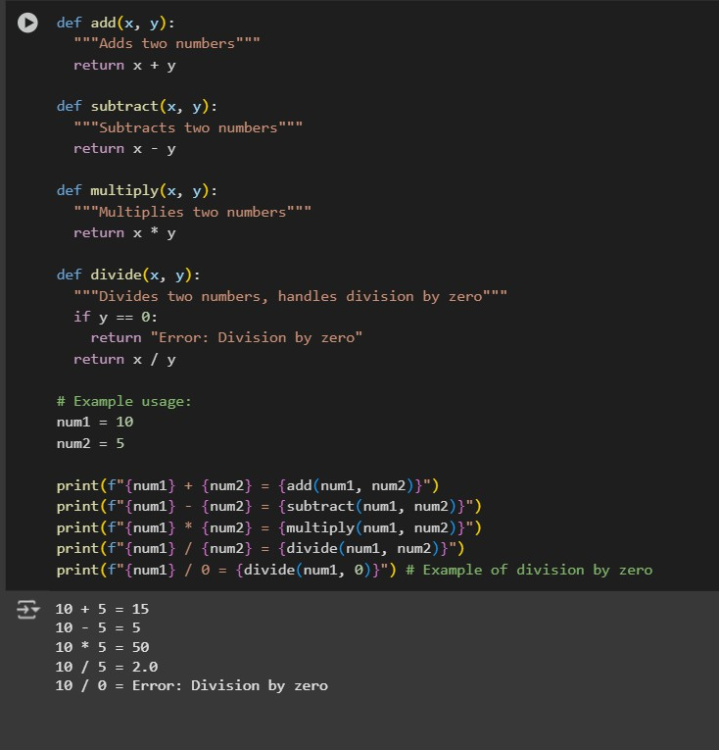
OBSERVATION: The simple calculator program successfully performed the basic arithmetic operations:

Task Description #5
- Use Cursor AI to create a Python program that checks if a given year is a leap year or not. Try different prompt styles and see how Cursor modifies its code suggestions.
Expected Output #5
- A functional program to check leap year with sample input/output
- At least two versions of the code (from different prompts)
- A short comparison of which version is better and why

ANSWER:
PROMPT:Python program that checks if a given year is a leap year or not. SCREENSHOT:
OBSE

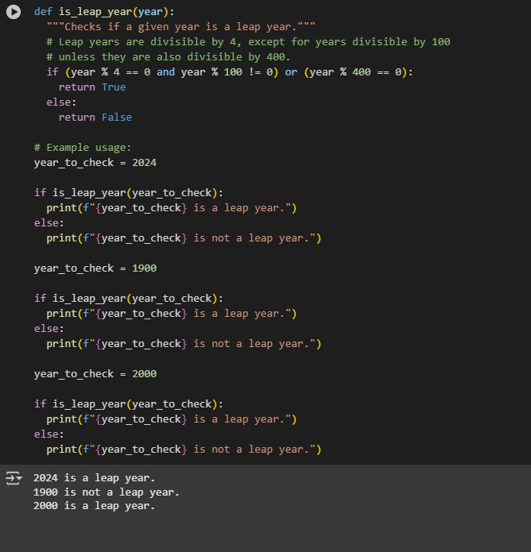
OBSERVATION:
- 2024 was correctly identified as a leap year.
- 1900 was correctly identified as not a leap year (as it is divisible by 100 but not by 400).
- 2000 was correctly identified as a leap year (as it is divisible by 400).

Note: Report should be submitted a word document for all tasks in a single document with prompts, comments & code explanation, and output and if required, screenshots

Evaluation Criteria:
 | Criteria | Max Marks
 | Two sorting implementations: Bubble sort (manual logic) and Built-in sort() (Task#1) | 0.5
 | Counts vowels, consonants, and digits(Task#2) | 0.5
 | Functional code that creates a .txt file, writes content to it, and reads it back- Use cursor (Task#3) | 0.5
 | Complete calculator code with user input and operation selection. (Task#4) | 0.5
 | A functional program to check leap year with sample input/output-use Cursor (Task#5) | 0.5
 | Total | 2.5 Marks

